Assignment 2

Task 1: Check if a Number is Even or Odd
Problem Statement: Write a Python program that:
1. Takes an integer input from the user.
2. Checks whether the number is even or odd using an if-else statement.
3. Displays the result accordingly.
Answer:

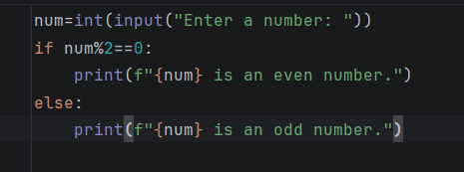
Output:

Input:
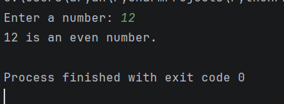
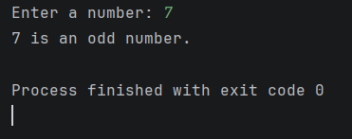

Task 2: Sum of Integers from 1 to 50 Using a Loop

Problem Statement: Write a Python program that:
1. Uses a for loop to iterate over numbers from 1 to 50.
2. Calculates the sum of all integers in this range.
3. Displays the final sum.
Answer:
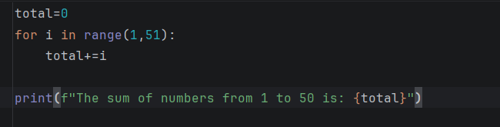
code:

Output:

